School Council meeting agenda 1st February 2024
The meeting will be led by the Head Boy and Head Girl.
- Welcome to our third School Council meeting for 2023-24 Minutes to be taken by…………?
- Please note -The School Council process for all School Council Members to follow. This is the process for your Year Council meeting.
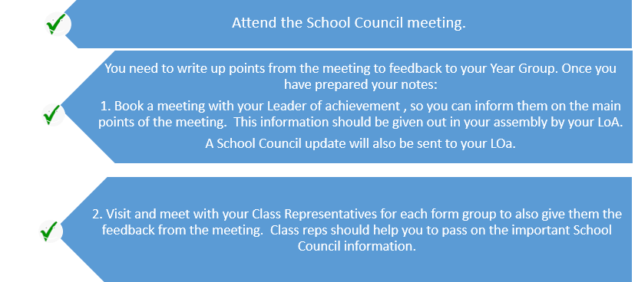
- Suggestions to briefly review- Please see list at end of agenda. - All School Council Members Serian/Josh to attend a meeting with Cleverchefs with Mr Ling.
- Global Group/Concert- Update on joining with Atlantic College for the 8th February concert. Zac, Yolay, James and Beatrice Poster attached.
- ECO update- Georgia and Nate Green Flag Status achieved!!!
- Where can we display the flag?
- Flag achieved but ECO projects at CS are ongoing e.g. recycling projects for the whole school. Please see recent email below:
Dear All In reflection of my last email. A new focus for our ECO Group will now be the points stated below. There will be a meeting for all the ECO Group and relevant staff after the mock exams, therefore, week commencing 29th January. I will email you all the week before to arrange a time and date.
1. Whole school recycling project- There will be an announcement on new laws about recycling in schools in April 2024. From April 6, 2024, it will be illegal for all businesses, charities and public sector organisations not to sort their waste for recycling. The list of who the law applies to is comprehensive, covering schools, universities, GPs, hospitality venues and prisons.
We will need recycling bins across the school, this will include any food areas as well. We could apply for funding or be part of a pilot. VOG Project Zero is a possible place to get funding. The websites below highlight how a school can recycle. https://www.gov.wales/sites/default/files/publications/2023-12/easy-read-separate-collection-of-waste-materials-for-recycling-a-code-of-practice-for-wales.pdf
https://participate.valeofglamorgan.gov.uk/hub-page/project-zero https://participate.valeofglamorgan.gov.uk/how-you-can-help
Or we could see if the school will be able to obtain funding due to the new laws coming into schools.
2.Mrs Thomas Lower School has given a great suggestion for our recycling project. We could aim to start our recycling project on global recycling day on 18th March 2024. Ideas could be, going into assemblies or showing a video about the plans we make for recycling at CS.
Update on ECO meeting: Applied to Project Zero and Energy Sparks Pilot Project -Mr Pope
Further litter picks needed due to year 8 suggestions and comments. Please see suggestions.
YCA Climate Change Application - Nic Adams email below
Dear Mrs Taylor-John
The YCA is excited to announce that we are looking for new members! There are two groups within our organisation: The Youth Climate Ambassadors, who lead decisions, and the Consultation Group, which provides feedback and influences discussions on YCA's work from diverse perspectives. YCA meets on a weekly basis, while the Consultation Group meets approximately three times per year. We are looking for 13-25 year olds who are passionate about climate change, want to have their voice heard, and are eager to develop key skills. If there are any questions I am more than happy to answer. An application form is attached below:
https://forms.gle/oHqb2vj4ad9EjP1HA
Thank you very much, Nic
- School Newspaper -Update A spring version of the newspaper? Zac and Beatrice
- CCS Sixth Form Blood Drive- Blood Drive at Cowbridge Leisure Centre FEBRUARY.The LINK has been sent- Sixth Form SC Members.
- Year 11 Prefect meeting (30th Jan) update- Serian and Josh Chess Club, Eco Wildflower planting- Lower School , CS Newspaper, Rock band, Debate Club, First Aid lessons , Healthy Breakfasts, Gym Club, Supporting younger students and Hygiene products for schools.
- Rotary update- Rotary boxes process started January-March 2024 Buy the boxes 6/02/24 and fill and hand in on 12/03/24
- Lounge Project for year 7’s feedback - Year 7 representatives
- Update on DFC and Money raised for Alzheimer's Research UK £233 DFC, Open day in Cowbridge and Helping at Southways/Longmeadow and Bluebird- Yolay
- Feedback-Student Ambassadors/children’s rights in December-Carwyn
- Make Your mark event organised for January-March 2024 -Ballots have been ordered.
Make Your Mark will launch its annual ballot of young people on 29th January - 8th March 2024. The UK-wide ballot gives young people aged 11-18 the opportunity to vote for the topics they feel are the most important issues facing young people locally and across the UK.
- Cancer Charity -Pop cake sales for Cancer Charities . 2nd and 5th February- World Cancer day 4th February. Marie Curie daffodils to sell February 19th to March 1st 2024.
- Disability Awareness meetings to start asap.
- Old School Uniform project- Mrs Stephenson Mr Ling-Could we simply discuss the principle of this idea and whether the School Council are happy to support the idea of a recycled uniform scheme which should be of benefit to all?
AOB-...................
Next SC Meeting Monday 4th March 2024
Suggestions- school- Suggestions will be sent to relevant staff. | Canteen- Suggestions to be given to Cleverchefs
Better photography facilities, maybe a bigger backdrop or classroom made into a photography studio so that it’s easier to access high grades. Because at the moment photography doesn’t have a proper place in school to take pictures. | Fix the food/Make the food better/marshmallows
Shorts in the summer x2 | i want the old food menu back
Why has the gym club stopped? | lower food prices, too much/lower school meal prices/Food prices
Non school uniform days to raise money x4 | food in school
Allowing mobile phones and normal conversations in the LRC. The only place that 6th formers can talk and study together is the canteen which is unacceptable. The study room is always quiet and usually filled with yr 13. Just use common sense.
Better queues for lunch - when your year is in third you often only have a few minutes to eat once you get in.
Girls rugby
Limits on homework including cooperative arrangements between pupil's teachers on how much is set taking into account a do-able amount to balance well with student's wellbeing
Get our phones back x2
please bring back phones. pretty please with cherries on top! xx😁😁😁
please bring back phones pretty please with cherries on top😘😘
Stop letting year 11’s into scholars to buy cans
Remove assemblies when there not necessary
get rid of reading morning x3
longer break x3 4 day week every week no school uniform
Have more school trips for year 11 as we have missed them all due to covid.
Any official word on school trips? Ski trip went ahead but nothing about the history trip to Berlin
Better recycling schemes/Climate change (we are currently sorting this)
I also think that there is a lot of litter around the campus and that there should be litter picking clubs or groups. There are so many wonderful people in this school who I know will be ( if provided with materials ) would be happy to help pick it up.

We do have lots of litter picking events!
Litter picking as punishment because it would encourage people not to litter
Art club
More separation between the male and female toilets. My friends and I purposefully drink less water so as to not need the loo in school. We know this is not healthy, however it is because we do not have many options. Nobody likes how the opposite gender can hear you use the facilities,because of this it is unhealthy for us not to be able to go to the toilets waiting all day is not good for our mental well-being.
Better and more toilet facilities especially for girls who really do need toilets in some cases urgently.
Could there be more student lead, focus groups eg ethnic minority, LGBT, female, neurodivergent, occasionally access to the library (a timetable to show when it’s available) as the scholars is difficult to work in after 2nd lesson, the study room is loud, the room by scholars is loud and lacks computers. More access and help with work experience.
Let us use the rugby field when warm ish and dry
Fix school clocks not many people have watches students might need the time for music lessons x2
More inside spaces at lunchtime
I think we should be aloud to fill our drinks and go to the toilet I know we have lunch and break to do it but I believe that people can’t help it and maybe they didn’t need the toilet or to fill up there drinks so if you would consider thank you
A pool in school
