Cowbridge comprehensive students and staff roll up their sleeves to help save lives.
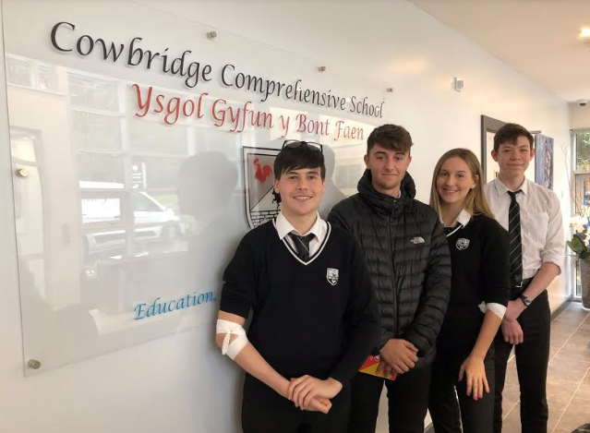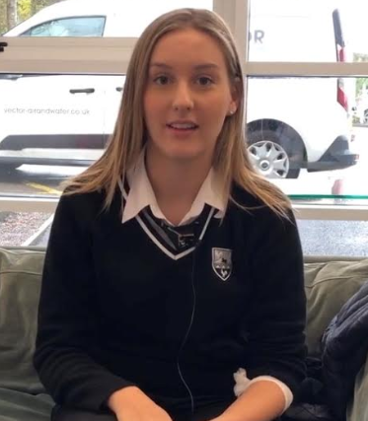
Students and staff from Cowbridge Comprehensive School have been thanked by the Welsh Blood Service for giving the gift of life by donating blood.
More than 50 blood donations were recently given at a blood donation session held at the school. This was the second donation session to be held at the school, with over 100 donations collected across the two sessions.
Mrs Debra Thomas, Headteacher at Cowbridge Comprehensive School, was full of praise for her students’ willingness to help others in need:
“We are very proud of our students for their commitment to saving lives. Every blood donation made can save up to three lives so collectively our pupils have already potentially saved over three hundred lives in Wales!
“I am immensely proud of the students and staff for helping us reach these incredible figures.”
After making her first donation, sixth form student Darcy said:

“Donating blood isn’t all that scary. It is really important for students to join the programme as the Welsh Blood Service is always in need of new donors, so I would definitely say ‘do it’. I’m so glad I did!”
In the two sessions held at the school, more than 30 students have signed up to the Welsh Bone Marrow Donor Registry, a database of over 35 million donors from across the globe whose unique bone marrow could make them the only person in the world capable of saving the life of someone in need of a transplant.
Cowbridge Comprehensive last year became the fourth school to start hosting blood donation sessions for its students and staff as part of the Welsh Blood Service’s comprehensive schools programme.
More than 1,300 donations have been taken at sixth form donation sessions to-date, enough to potentially save or improve the lives of more than 3,900 adults or 7,800 babies. Over 150 students have also signed up to the Welsh Bone Marrow Donation Registry.
Based on the success of schools like Cowbridge Comprehensive, the Welsh Blood Service recently launched an initiative to increase the number of schools hosting their very own donation sessions. New venues have since been established at: Monmouth Schools for Girls, alongside Monmouth School for Boys and Monmouth Comprehensive School; Olchfa (Swansea); Bassaleg (Newport); Y Pant (Talbot Green) and Whitchurch High School (Cardiff).
The new schools will help the Welsh Blood Service secure an additional 300 first time donors every year, with more eligible schools expected to join the programme in 2020.
Alan Prosser, Director of Service at the Welsh Blood Service said:
“We would like to thank the students and the members of staff who have selflessly contributed towards the 100,000 donations needed in Wales each year. They have shown fantastic commitment and great community spirit.
“It’s essential that we pass on how important donating blood is to the younger generation. By having the support of some of the largest schools in Wales, we can encourage more students to try donating as part of their school day. We hope that the actions of these students will encourage more people living in Wales to consider donating in the future.
“The blood collected is not just used for accidents and emergencies; it is also used for cancer and leukaemia patients who need regular transfusions, so it’s crucial we maintain a steady supply to support patients in need across the country.
“If you have never donated before, now is a great time to try.”
To start your lifesaving journey today, please visit wbs.wales/schools or call 0800 252 266 to find your local donation clinic.
ENDS

For further information, please contact Communications Officer, Simon Campbell-Davies on 01443 622189, available weekdays between 9.00am and 5.00pm.

Notes to the editor:

- Upcoming blood donation sessions around Cowbridge:

Date | Location | Time
2 Dec | Welsh Blood Service HQ, Talbot Green | 12:00 – 14:50 & 16:00 – 19:30
9 Dec | Bridgend, Heronston Hotel | 10:00 – 12:30 & 14:00 – 16:20
19 Dec | Rhoose Community Centre | 13:00 – 17:30
17 Jan | Pencoed, Pencoed Rugby Club | 14:00 – 18:30
20 Jan | Bridgend Life Centre | 10:00 – 12:30 & 14:00 – 18:00
21 Jan | Cowbridge Leisure Centre | 14:00 – 18:30

About the Welsh Blood Service (WBS)
- WBS supply blood to 19 hospitals across the whole of Wales.
- WBS host around 1,600 each year across 400 venues in Wales to collect the 100,000 units of blood it needs to supply its hospitals.
- Anyone aged between 17 and 66, who weighs over 50 kg (7st 12lb) can become a blood donor but there are height and weight restrictions for females under 20 years old.
- There is no upper age limit for donors who have donated in the last two years.
- The blood we collect is not just used for accidents and emergencies – cancer and leukaemia patients need regular transfusions.
- O Negative supplies are vital as this group is known as the universal donor as it can be used to treat any patient in an emergency.
- O Positive is the most common blood group in Wales.
- Blood can’t be stockpiled – its short shelf life means stocks have to be replenished on a daily basis.
- All blood donations are tested for: HIV (the aids virus); Hepatitis B; Hepatitis C; HTLV (Human T Lymphotropic Virus) and Syphilis.
- There are four blood groups – A, AB, B and O each of which will be either Rhesus Negative or Rhesus Positive.
- WBS also hosts the Welsh Bone Marrow Donor Registry, blood donors aged between 17 and 30 can join the database which is searched every day to find suitable donor-patient matches across the World.

English
https://www.welsh-blood.org.uk/cowbridge-comprehensive-students-and-staff-roll-up-their-sleeves-to-help-save-lives/

Welsh
https://www.welsh-blood.org.uk/cy/cowbridge-comprehensive-students-and-staff-roll-up-their-sleeves-to-help-save-lives/

